Docker Project – docker-node-app
Step 1: Create Project Folder

Open Command Prompt / PowerShell

👉 Run:

mkdir docker-node-app
cd docker-node-app

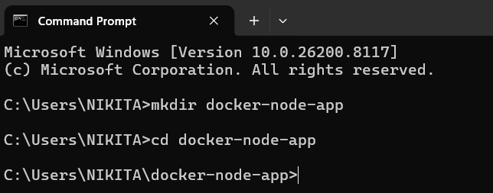

This will:
- Create a folder named docker-node-app
- Move inside that folder.

Step 2: Create Application Files

Now we will create the basic Node.js app files

- Create app.js

Inside your folder:

Using Command Line:

👉 Run: notepad app.js

Paste this code

const http = require('http');

http.createServer((req, res) => {
res.end("Hello from Docker ");
}).listen(3000);

Save and close

2. Create package.json
Inside your folder:

Using Command Line:

👉 Run: notepad package.json
Paste this code

{
"name": "docker-node-app",
"version": "1.0.0",
"main": "app.js"
}
Save and close

- Verify Files

👉 Run: dir

You will see in command prompt

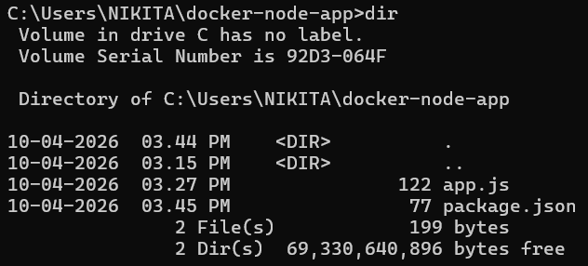

Step 3: Create Docker file

This file tells Docker how to build your application

- Create Dockerfile

👉 Run: notepad Dockerfile

Paste this code

FROM node:18-alpine

WORKDIR /app

COPY . .

EXPOSE 3000

CMD ["node", "app.js"]

Save and close

- Verify Files

👉 Run: dir

You will see in command prompt

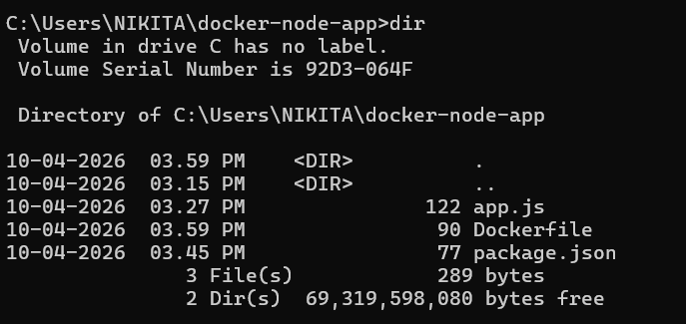

Step 4: Build Docker Image

This step will convert your code into a Docker Image

- Run Build Command

Inside your project folder,

👉 run: docker build -t node-app .

Understand the Command
- docker build → Build an image
- -t node-app → Name your image
- . → Current folder (where Dockerfile is present)

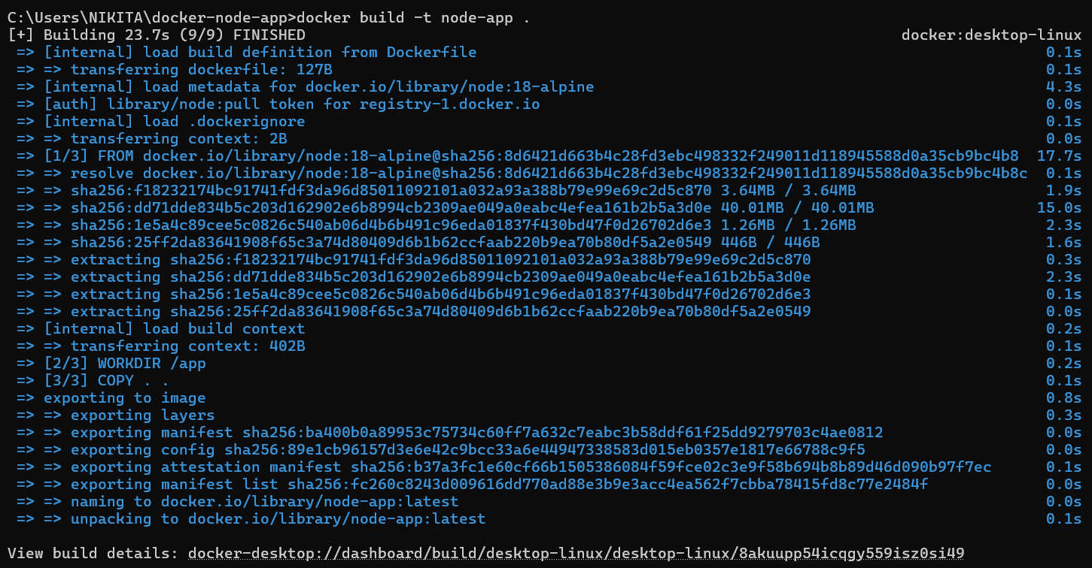

- Verify Image

👉 Run: docker images

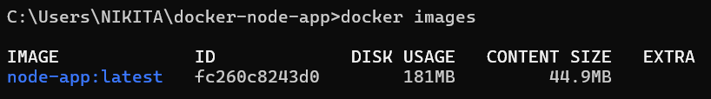

Step 5: Run Docker Container

  - Run Command

docker run -d -p 3000:3000 node-app

- docker run → Run container
- -d → Run in background
- -p 3000:3000 → Port mapping
  - Left = your laptop
  - Right = container
- node-app → Image name

  - Check Running Container

Run: docker ps

👉 You should see your container running ✅

- Test Application

Open browser:
http://localhost:3000

👉 Output:

